

V 1.2
June 2026
XStep Design Specification
SMPL: Initial Water Addition

Table of Contents
1 Purpose 3
2 Overview 3
3 Reasons for developing 5
4 Authorization 5
5 Assumptions/ Dependencies 5
6 Validation Checks 5
7 Configuration Specification 6
8 XStep Layout Design 6
9 Function Module(s) 7
10 Pseudocode 10
11 Test Scenarios 15
12 Revision History 16

Purpose
This document outlines the design, along with the configuration specifications for the XStep “SMPL: Initial Water Addition”.

Overview
This SMPL: Initial Water Addition XStep guides the operator through the initial charging of Water for Injection (WFI) into the mixing vessel. The operator is instructed to add the required volume of WFI based on values calculated in the preceding table.
The SMPL: Initial Water Addition XStep ensures that the correct quantity of water is introduced at the start of the mixing process, supporting consistent batch preparation.
The XStep contains two main input parameters:
- IV_HEADER - This can be changed in SiMPL MBR to display specific header text for the XStep
- IV_INSTR - This can be changed in SiMPL MBR to display a specific set of instructions for the XStep that will be displayed below the header
- IV_PO_QTY – This is used in SiMPL MBR to reference the batch size adjustment from the Top-Off step, if available. More details to configure this will be found in the Parameter Reference document.
- IV_TMAX – This can be authored in SiMPL MBR to determine the maximum value range against which the Temperature Recording will be validated.
- IV_TMIN – This can be authored in SiMPL MBR to determine the minimum value range against which the Temperature Recording will be validated.
- IV_SIGN – This can be changed in SiMPL MBR to author standalone signatures as part of the xstep.

When the PI Sheet is opened, the following fields are auto-populated into the Water Addition table:
- “Component” - Output
- “Min” - Output
- “Max” - Output
- “UoM” - Output
The operator enters the valve number and the equipment ID:
- “Valve No” - Input
The operator records the temperature reading, which must fall within the specified range defined:
- “Temperature” - Input
- “UoM” - Input
If the value is outside of the defined min and max fields, a deviation is recorded.
The function module ZSMPL_FM_CALC_WFI calculates the required quantity based on the following calculation:
Required Amount = Order Qty x [ Base Component Qty (1) - Sum of other base component quantities on the BOM (0.XXX) ]
The required amount will also be re-calculated if the batch size changes in the case of a Top-Off Solution.
The Component Amount is calculated by:
Required Amount = [ Base Component Qty (1) - Sum of other base component quantities on the BOM (0.XXX) ]
The operator confirms the Required Amount and the Component Amount:
- “Required Amount” - Output
- “Component Amount” - Output
The operator manually records the amount measured on the scale:
- “Measured Amount” - Input

The measured amount is validated within a 2% tolerance range via the ZSMPL_FM_VALIDATE_ISSUED_QTY, which triggers a deviation for both under and overweight.
Upon entering the weight values the function module - ZSMPL_FM_GET_DATE_AND_TIME automatically retrieves the current system date and time without requiring manual input. The retrieved values are then populated in the following fields:
- “Water Pull Date” - Output
- “Date” - Output
The individual performing this selection then records their signature in the “Performed By” field.
Functional Design
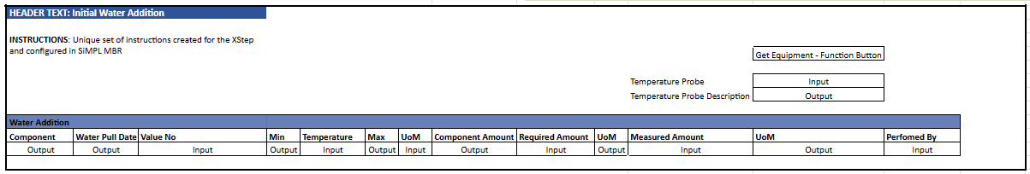

Reasons for developing
The development of the “SMPL: Initial Water Addition” XStep will be developed to ensure precise and traceable control over the initial charging of Water for Injection (WFI) into the mixing vessel during batch preparation.

Authorization
N/A

Assumptions/ Dependencies
 | Assumption
1 | Operator signing signature fields is an approved operator in the system with the correct access configuration
2 | Master Data has been set up correctly
4 | The function module can successfully pull the data into the output fields

Validation Checks
Error Handling
Error | Action
Operator Signature rejected due to an incorrect username or password | Operator accepts error message and re-enter the correct username and password
Min and Max temperature fields not pre-populated by default | Check MBR Configuration
Measured Amount value is not within 2% tolerance range of required amount | Operator accepts error message and re-enter the correct username and password, or enters new measured amount

Configuration Specification
N/A

XStep Layout Design
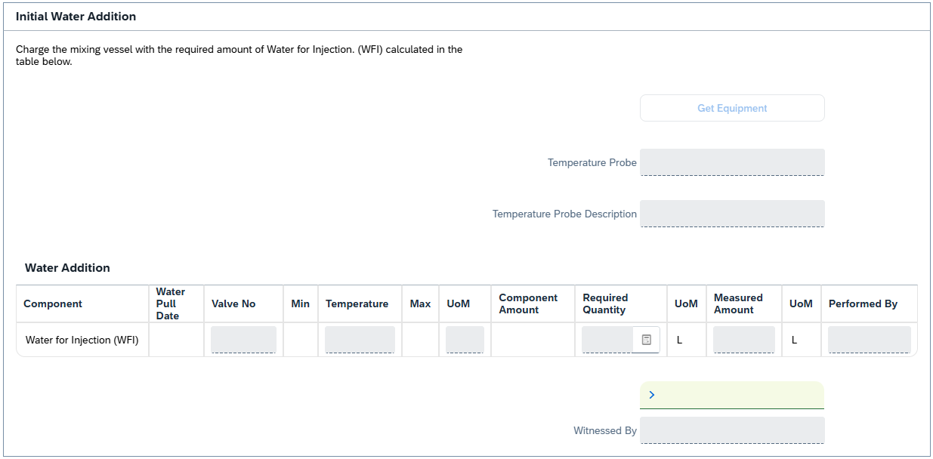

Function Module(s)
Function: ZSMPL_FM_GET_DATE_AND_TIME
Import Parameters:
Parameter Name | Associated Type | Short Text
IV_USER | CHAR30 | User

Export Parameters:
Parameter Name | Associated Type | Short Text
EV_DATE | TYPE | ZSMPL_DE_START_DATE
EV_TIME | TYPE | ZSMPL_DE_START_TIME

Function: /SMPL/PPPI_FM_SIG_ADD_DB_CB
Import Parameters:
Parameter Name | Associated Type | Short Text
IM_CONTROL_RECIPE | POC_DOCID | Control Recipe Number
IM_PHASE | VORNR | Activity Number
IM_STEP_IDX | INT4 | XStep Step Index Number
IM_STEP | CHAR30 | XStep Header
IM_SIGTYPE | CHAR20 | Signature Type
IM_USERID | XUBNAME | User Name
IM_DB_UP_DOWN | CHAR1 | Done By Up/Down
IM_VALIDATION_REQ | CHAR3 | Validation Required
IM_STEP_UUID | ZSMPL_DE_SMPL_SOG_UUID | XStep SOG UUID

Function: /SMPL/PPPI_FM_INITIAL_ACTIVE
Import Parameters:
Parameter Name | Associated Type | Short Text
IV_ACTIVE | CHAR1 | N/A
Export Parameters:
Parameter Name | Associated Type | Short Text
EV_ACTIVE | CHAR1 | N/A

Function: /SMPL/MBR_DEP_CHECK_ACTIVE
Import Parameters:
Parameter Name | Associated Type | Short Text
IM_CONTROL_RECIPE | POC_DOCID | N/A
IM_PHASE | VORNR
IM_AUFNR | AUFNR
IM_STEP_UUID | /SMPL/MBR_SOG_UUID
IM_PLANT | WERKS_D

Export Parameters:
Parameter Name | Associated Type | Short Text
EV_ACTIVE | CHAR1 | N/A

Exceptions:
Exception | Short Text
CONTROL_RECIPE_INITIAL

Pseudocode
Function: ZSMPL_FM_GET_DATE_AND_TIME
1. Purpose
Returns the current local system date and time for the calling user session.
This is commonly used to timestamp process events, user actions, or to synchronize MES events with local user context (as opposed to server or UTC time).
2. Input Handling
- IV_USER (optional):
  - A 30-character string representing the user requesting the date and time.
  - This parameter is not used in the logic but may be intended for future auditing or user-specific enhancements.
3. Time and Date Retrieval
a. Retrieve local date and local time from system fields:
- EV_DATE = SY-DATLO
  - Returns the local date based on the user’s time zone (not the application server time zone).
- EV_TIME = SY-TIMLO
  - Returns the local time based on the user’s session context.
These system fields (SY-DATLO, SY-TIMLO) automatically adjust based on the logged-in user’s SU01 time zone settings.
4. Output Assignment
- EV_DATE: Populated with the local date (ZSMPL_DE_START_DATE format).
- EV_TIME: Populated with the local time (ZSMPL_DE_START_TIME format).
5. Additional Notes
- Simplicity: The function has no complex logic, conditions, or error handling.
- Performance: It executes instantly and deterministically.
- Use Case: Suitable for time-stamping user actions in MES scenarios where the user’s local time context is critical (e.g., batch sign-offs, weigh-ins, or electronic signatures).
- Error Handling: Not required due to the simplicity and reliability of system field access.
- Dependencies: None. It operates entirely based on standard system fields.

Function: /SMPL/PPPI_FM_SIG_ADD_DB_CB
- Signature Type Identification
- Assign the incoming signature type (IM_SIGTYPE) to local variable lv_sigtype.
- A CASE structure is used to determine behavior based on the type:
  - ' ' (Done By)
  - 'C' (Checked By)
  - 'O' (Validation Flag Only)
- Done by Signature(lv_sigtype = '')
a. Optional Step Name Update
- If IM_STEP is provided, update the XStep header in table /SMPL/PPPI_PISST.
b. Determine Position for Signature Insertion
- If IM_DB_UP_DOWN is empty:
  - Insert the new signature above the current item by fetching MIN(UNIQUE_SEQID) and inserting one row before it.
- If IM_DB_UP_DOWN = 'B':
  - Insert the new signature below the current item by fetching MAX(UNIQUE_SEQID) and inserting one row after it.
- In both cases:
  - Use IM_USERID as the signer (SIGN_ID)
  - Signature type description from TEXT-001
  - Insert new row into /SMPL/PPPI_PISST
- Checked By Signature (lv_sigtype = 'C')
a. Get Signature Start Point
  - Select the UNIQUE_SEQID of the "Checked By" step matching the given input.
b. Determine Signature End Point
- Fetch all prior 'C' type signatures for the same control recipe (and optionally across all phases).
- Determine the highest UNIQUE_SEQID lower than the start point to use as the end.
c. Update Checked By Step
- Set the SIGN_ID and mark the step as COMPLETED = 'X'.
d. Complete All Steps Between Start and End
- Fetch and loop over all steps with UNIQUE_SEQID between the start and end boundaries.
- Mark each row in that range as COMPLETED = 'X'.
- Update the database using MODIFY.
- Validation Flag Update (lv_sigtype = 'O')
a. Determine Validation Value
  - If IM_VALIDATION_REQ = '2', set to 'No', else 'Yes'.
b. Update Validation Requirement
- Update the VALIDATION_REQUIRED field for the current control recipe, phase, and step index in /SMPL/PPPI_PISST.
Additional Notes:
- Purpose:
Dynamically inserts or updates signature records in /SMPL/PPPI_PISST depending on the role of the signer (Done By, Checked By, or Validator).
- Features:
Supports step name overrides and UUID tracking.
Allows insertion before or after specific records using IM_DB_UP_DOWN.
Ensures Checked By signatures cascade completion to preceding steps.
Accommodates flexible validation logic.
- Error Handling:
No explicit RAISE statements or exception handling.
Relies on CHECK and SY-SUBRC evaluations to exit silently if lookup conditions fail.
- Extensibility:
Designed with optional parameters (IM_STEP, IM_SIGTYPE, IM_DB_UP_DOWN, IM_VALIDATION_REQ) to support various signing scenarios.

Function: /SMPL/PPPI_FM_INITIAL_ACTIVE
1. Initialization
a. Input parameter IV_ACTIVE is optionally provided by the calling logic.
b. Constants gc_yes, gc_no, and gc_inside_range are assumed to be defined globally in the context of the function module.
2. Active Flag Evaluation
a. The function checks if the input value IV_ACTIVE falls within the expected valid range, represented by gc_inside_range.
b. Based on the result:
- If the input value is not equal to gc_inside_range, the XStep is marked as inactive by setting EV_ACTIVE = gc_no.
- If the input value is equal to gc_inside_range, the XStep is marked as active by setting EV_ACTIVE = gc_yes.
3. Output Assignment
a. The evaluated result is returned in the EV_ACTIVE export parameter for use by the calling logic (e.g., XStep configuration, PI sheet rendering).
Additional Notes
- This is a simple normalization function that abstracts how activation flags are interpreted for PPPI XSteps
- The use of constants (gc_yes, gc_no, and gc_inside_range) allows the logic to be aligned with broader application settings or standards.
- Helpful in scenarios where input values may vary but need to result in consistent "active" or "inactive" behavior.
- Input is optional, so defaulting behavior can be configured outside this function.
- This function improves clarity and consistency in determining whether an XStep should be active when rendered in the PI Sheet.

Function: /SMPL/MBR_DEP_CHECK_ACTIVE
1. Initialization
a. Input parameters provide context for determining whether an MBR (Manufacturing Batch Record) step can be activated:
- IM_CONTROL_RECIPE (POC_DOCID) – Control recipe ID identifying the batch instruction.
- IM_PHASE (VORNR) (Optional) – Operation or phase within the process order.
- IM_AUFNR (AUFNR) (Optional) – Process order number associated with the step.
- IM_STEP_UUID (/SMPL/MBR_SOG_UUID) – Unique step identifier (SOG).
- IM_PLANT (WERKS_D) – Plant code for process context.
b. The function first validates that IM_CONTROL_RECIPE is not initial.
- If it is initial, the exception CONTROL_RECIPE_INITIAL is raised.
c. Internal data is initialized:
- lt_ord_sigs: Internal table for storing order signature data from /SMPL/MBR_OR_SIG.
- ls_step_dep: Work area for step dependency data.
- Routine LOAD_INTERNAL_DATA is called to populate internal buffers (g_ord_data-t_ord_deps) using IM_AUFNR, IM_CONTROL_RECIPE, and IM_STEP_UUID.
2. Signature Data Retrieval
a. The function retrieves signature records for the process order from database table /SMPL/MBR_OR_SIG.
b. Selected fields include: AUFNR, SOG_UUID, TYPE, CREATED_DATE, CREATED_TIME, DEST_NAME, SIGN_ID, SIGN_DATE, and SIGN_TIME.
c. Only signatures related to the specified order (AUFNR = IM_AUFNR) are selected.
d. These records are stored in the internal table lt_ord_sigs for later evaluation.
3. Dependency Evaluation
a. The function loops through dependencies in g_ord_data-t_ord_deps where:
- TARGET_UUID = IM_STEP_UUID, and
- DEP_RULE is either gc_perform_before_start_rule or gc_verify_before_start_rule.
b. For each dependency record:
- If the rule is PERFORM BEFORE START, it checks whether the prerequisite step (PREREQ_UUID) has a pending perform signature (gc_perform_signature) with SIGN_ID = abap_false.
- If the rule is VERIFY BEFORE START, it checks whether the prerequisite step (PREREQ_UUID) has a pending verify signature (gc_verify_signature) with SIGN_ID = abap_false.
c. If an incomplete signature is found, the step is marked inactive (EV_ACTIVE = gc_step_inactive).
d. If all prerequisite signatures are complete, the step is marked active (EV_ACTIVE = gc_step_active).
4. Output Assignment
a. The evaluated activation status is returned in the export parameter EV_ACTIVE.
- gc_step_active – All prerequisite steps are completed; the current step can start.
- gc_step_inactive – At least one prerequisite step is incomplete; the current step remains blocked.
Additional Notes
This function determines whether a dependent step in a Manufacturing Batch Record is eligible to start based on the completion of prerequisite steps.
Key Features:
- Evaluates Perform Before Start and Verify Before Start dependency rules.
- Dynamically validates signature data from /SMPL/MBR_OR_SIG.
- Integrates with existing MBR dependency structures via global table g_ord_data-t_ord_deps.
Error Handling:
- Raises CONTROL_RECIPE_INITIAL if the control recipe input is missing.
- Handles empty dependency or signature data without runtime errors.
Dependencies:
- Tables: /SMPL/MBR_OR_SIG (Signatures), g_ord_data-t_ord_deps (Step Dependencies).
- Constants: gc_perform_before_start_rule, gc_verify_before_start_rule, gc_perform_signature, gc_verify_signature, gc_step_active, gc_step_inactive.
- Routine: LOAD_INTERNAL_DATA for initializing order context.
Assumptions:
- All prerequisite steps are recorded in the dependency table.
- Signature records are current and synchronized with MBR step progression.
- Activation status is recalculated each time the function is called to reflect live signature data.

Test Scenarios
# | Scenario | Expected Result | Actual Result | Pass/ Fail
1 | Create and Release a Process Order with the pre-configured SiMPL Master Recipe and the relevant Production Version | Process Order created and Released containing SMPL: Initial Water Addition | Process Order created and Released containing SMPL: Initial Water Addition
2 | Open the EBR, and navigate to SMPL: Initial Water Addition | The EBR for the selected Process Order and Control Recipe opens successfully without any errors and the SMPL: Initial Water Addition is visible | The EBR for the selected Process Order and Control Recipe opens successfully without any errors and the SMPL: Initial Water Addition is visible
3 | Verify that the value/text entered in parameter IV_HEADER and parameter IV_INSTR in SiMPL MBR appears correctly in the XStep header | Header and instruction text are displayed as authored in SiMPL MBR | Header and instruction text are displayed as authored in SiMPL MBR
4 | The operator verifies that the following fields are auto-populated in the Water Addition Table: Component, Min, Max, UoM. | Component, Min, Max and UoM values are auto-populated in the Water Addition Table. | Component, Min, Max and UoM values are auto-populated in the Water Addition Table.
5 | The operator enters values in the following input fields: Valve No, Temperature, Required Amount and Measured Amount. | All input values are accepted and within range. | All input values are accepted and within range.
6 | Enter a username in the “Performed By” field then enter the password in the pop-up window. | Signature is accepted | Signature is accepted
7 | Verify that the Water Pull Date and Date auto-populated once the first signature is executed. | Water Pull Date and Date auto-populates. | Water Pull Date and Date auto-populates.
8 | Enter a username in the “Witnessed By” field then enter the password in the pop-up window. | Signature is accepted and the xstep locks. | Signature is accepted and the xstep locks.

Revision History
Version No. | Description | Author | Date
1.1 | Initial Document (Functional Requirements and Technical Specification) | Karla Uys and Frieda van der Merwe | 23-07-2025
1.2 | The following Technical Spec sections added to spec: Function Module(s), and Pseudocode. | Juna Jaouhari | 19-06-2026

